

**A PROJECT REPORT ON**

***ONLINE CRIME REPORTING SYSTEM***

**TO THE SAVITRIBAI PHULE PUNE UNIVERSITY**

### SUBMITTED BY :

#### 1.Umesh Mali

#### 2.ShubhamGhotekar

#### 3.Siddharth Kakde

**DEPARTMENT OF COMPUTER ENGINEERING**

**KEYSTONE SCHOOL OF ENGINEERING,**

**PUNE**





# CERTIFICATE

***ONLINE CRIME REPORTING SYSTEM***

#### SUBMITTED BY

1. **Umesh Mali (72222063E)**

#### Shubham Ghotekar

#### Siddharth Kakde

is a bonafide student of this institute and the work has been carried out by him under thesupervision of **Prof. Amrin Shaikh** and it is approved for the partial fulfillment of the requirement of Savitribai Phule Pune University

**(Prof. Amrin Shaikh) (Prof. Sagar Rajebhosale)**

Faculty In-charge Head of Department Department of Computer Engineering Department of Computer Engineering

Principal

Keystone School of Engineering, Pune Place: Pune

Date :

**Keystone School of Engineering, Pune**

**Department of Computer Engineering**



**ACKNOWLEDGEMENT**

Through the acknowledgement, we express our sincere gratitude to GOD and all those people who have associated with this assignment and have helped with it and made it a worthwhile experience. We take immense pleasure in ranking **Dr.Sandeep Kadam**, Principal of Keystone School of Engineering, Pune for her kindness that has enabled his project to be complete one. We wish express our deep sense of gratitude to the Head of Department **Prof. Sagar Rajebhosale,** for there excellent guidance and constant encouragement to successfully complete this project.

We wish to express our heartfelt thanks to our internal guide **Prof. Amrin Shaikh** ,for her valuable guidance, readiness to clear all doubts and for guiding in the right way to make this project a successful one. Also we extend our thanks to the various people who have shared their opinion and experience through which we received information crucial for our report.Finally, yet importantly, we would like to express our heartfelt thanks to our beloved parents for their blessings, our friends/classmates for their help and wishes for the successful completion of this project.

**1. Umesh Mali**

#### 2. Shubham Ghotekar

**3. Siddharth Kakde**

**ABSTRACT**

The rate of crimes is increasing day by day in all societies across the world. “**Online Crime Reporting System**” using this website people who are afraid or don’t have enough time to go police station for complaint about their personal issues hereby they can give their complaint through online. The objective is to develop a web based application using which people can report the crime online. It provides the facility of uploading images or videos of crime scenes so that police can take action immediately. The system registers the complaint from people through online and it will also helpful to police department in catching criminals quickly. It also provides the public alerts.

By this website public and police are both benefitted as its reduces the time and increases the chance of solving the case, which then reduces the crime rate. The aim of this project is to develop an online crime report and managing system which is easily accessible to the public and user friendly.

There are mainly three users in this system:

1. Head Quarter
2. Police Station
3. User

#### CONTENTS

**TITLE PAGE NO**

INTRODUCTION 7-8

* 1. Project an Overview. 7
  2. Objectives. 8

1. SYSTEM ANALYSIS 9-11
   1. Introduction. 9
   2. Existing System 9
   3. Proposed System 10
   4. Feasibility Study 11
2. SYSTEM ENVIRONMENT 12-15
   1. Introduction. 12
   2. Hardware Requirement. 12
   3. Software Requirement. 15
   4. Development Tools. 15
3. SYSTEM DESIGN 16-27
   1. Introduction. 16
   2. Process Design. 17
   3. ER Diagram 18
   4. Use Case Diagram 19-20
   5. Database Design 21-22
   6. User Interface Design. 23-27
4. SYSTEM TESTING 28
   1. Introduction. 28

Unit Testing. 28

Integration Testing. 28

Validation Testing. 28

1. FUTURE ENHANCEMENT 29
2. CONCLUSION 30
3. BIBILOGRAPHY 31

1. **INTRODUCTION**

## OVERVIEW

The rate of crimes is increasing day by day in all societies across the world, but we do believe that there is a lot which can be done by both the governments and the individuals to reduce the crimes in communities. In current scenario, we had to visit the police station to register the complaint which is a time consuming process.

Online Crime Reporting System in which public and police are both benefitted as its reduces the time and increases the chance of solving the case, which then reduces the crime rate. By using this website people who are afraid or don’t have enough time to go police station for complaint about their personal issues hereby they can give their complaint through online**. The aim of this project is to develop an online crime report and managing system which is easily accessible to the public and user friendly.** The system registers the complaint from people through online and it will also helpful to police department in catching criminals quickly. It also show most wanted person.

**OVERVIEW:**

* + - Responsive Database System.
    - Manages the records.
    - Save Time.
    - Generates report

**SCOPE:**

* To provide maximum services to the public.
* Faster response.
* To reduce the paper work.
* Generates reports requires from time to time analysis.
* User Friendliness.

## OBJECTIVES

Crime reporting system is an application designed for avoiding the complexity of the existing system. The existing system mainly depend up on the paper work. The existing system is time consuming. By computerized system can easily manage the whole system. It also provides better security and reliability for data.

The **Objective** of Crime Reporting System is to develop a website using which people can report crime online. It provides the facility of uploading images or videos of crime scenes so that police can take action immediately. It also provides the information of most wanted criminals.

# SYSTEM ANALYSIS

## INTRODUCTION

System analysis is a general term that refers to an orderly, structured process for identifying and solving problems. We call system analysis process lifecycle methodology, since its relates to four significant phases in the life cycle of all the business information system. The life cycle is divided into four phases.

They are,

* + - Study Phase
    - Design Phase
    - Development Phase
    - Implementation Phase

In the study phase, detailed study of the project is made and clear picture of the project should be in mind by this time. In the design phase designing of the input-output of the table and development phase is the physical designing of the input output screens and coding of the system. System implementation actually implements in the system by making necessary testing.

## EXISTING SYSTEM

In the existing system most of the operations are done manually like send complaints, view status etc…The existing is time consuming and not very user friendly. Existing crime reporting system does not have such medium by users can place their complaints from any location. They have to visit their nearest police location and take copy of complaints for future reference.. Many citizens hesitate to visit any police station and thus informer information cannot be kept confidential .If any citizen sufferer of crime, even after dialing emergency number, police person do not able to locate the exact location of that citizen.

**DISADVANTAGES OF EXISTING SYSTEM**

* + - More man power.
    - Time Consuming.
    - There is no centralized control over the whole process.
    - Lack of flexibility.
    - Lack of accurate information flow cause the whole process to slow down.

## PROPOSED SYSTEM

The aim of proposed system is to develop a system of improved facilities. The proposed system overcomes the disadvantages of the existing system. The system reduces the manual work. The existing system has several disadvantages and many more difficulties to work well. The proposed system tries to eliminates or reduce these difficulties up to some extent. The proposed will help the user to reduce the workload and mental conflict. The proposed system helps the user to work user friendly and he can easily do his jobs without time lagging.

ADVANTAGES OF PROPOSED SYSTEM

* + - Ensure data accuracy’s.
    - Minimize manual data entry.
    - Greater efficiency.
    - Better Services.
    - User friendliness and interactive.
    - Minimum time required.
    - Less man power.

## FEASIBILITY STUDY

The main aim of this phase is to identify whether it would be financially and technically feasible. The feasibility study activity involves analysis of the problem and collection of all relevant information relating to the product such as the different data items which would be input to the system, the processing required to be carried out on these data, the output data required to be produced by the system.

The key points in the feasibility study are:

* **Economical Feasibility**
* **Technical Feasibility**
* **Behavioural Feasibility**
  + - **Economical Feasibility**

It is the most frequently used method for evaluating the effectiveness of the system. It is also known as cost benefit analysis, the procedure is to determine he benefits and savings that are expected from the system and compare them with cost. We analyze the candidate system is feasible than the manual system because it saves money, time and man power. It also feasible according to cost benefit analysis.

* + - **Technical Feasibility**

It involves the financial consideration to accommodate technical enhancement. If the budget is serious constraint then the project is not judged not feasible. Technical feasibility centers on the technology used. It means the candidate system is technically feasible i.e., it doesn’t have any technical fault and work properly in the given environment; it is providing us required output.

* + - **Behavioural Feasibility**

It is specify the system is behaviorally feasible to user. It determines introduce a new system how that system is effectively used by the user. It is the analysis of the candidate system. In this we analyze that the candidate system is working properly or not. If working than it communicating proper with the environment or not. All this matters are analyzed and a good candidate system is prepared. Due to the change of system what is the change in behavior of the users, this factors are also analyzed.

1. **SYSTEM ENVIRONMENT**

#### Introduction

The selection of hardware and software requirements is very important. In sufficient Random Access Memory may affect adversely on the speed and efficiency on the entire system. The processor should be powerful to handle the entire operations. The hard disk should have sufficient capacity to store the file applications. This system can be run on any running under Windows platform. It is developed using the high level programming language PHP.

#### Hardware Requirements

The selection of hardware configuration is very important task related to the software development. Insufficient Random Access Memory may affect adversely on the speed and efficiency of the entire system. The processor should be powerful to handle the entire operations. The hard disk should have sufficient capacity to store the file application.

* + - Memory : 4 GB or greater
    - Operating System : Any Operating system
    - Database : MySQL

###### **Client Requirements:**

Any PC with internet connectivity will serve the client side operations.

#### Software Requirements

###### **Server Requirements:**

* + - Operating System : Window 11
    - Database : MySQL
    - Web server : XAMPP Server
    - Browss er : Any Web Browser Supporting HTML5
    - Other : PHP

#### Development Tools

1. **PHP**

PHP is a server side scripting language designed for web development but also used a general-purpose programming language. The **PHP Hypertext Preprocessor (PHP)** is a programming language that allows web developers to create dynamic content that interacts with databases. PHP is basically used for developing web based software applications. It is used to manage dynamic content, databases, session tracking, even build entire e-commerce sites. It is integrated with a number of popular databases, including MySQL, Oracle, Sybase, Informix, and Microsoft SQL Server.

**Common Uses of PHP**

PHP performs system functions, i.e. from files on a system it can create, open, read, write, and close them. The other uses of PHP are:

* + - PHP can handle forms, i.e. gather data from files, save data to a file, thru email you can send data, return data to the user.
    - You add, delete, modify elements within your database through PHP.
    - Access cookies variables and set cookies.
    - Using PHP, you can restrict users to access some pages of your website.
    - It can encrypt data.

**Characterstics of PHP:**

Five important characteristics make PHP's practical nature possible −

* + - Simplicity
    - Efficiency
    - Security
    - Flexibility
    - Familiarity

#### B.MySQL

MYSQL is an open-source relational database management system (RDBMS). MySQL is free and open-source software under the terms of the GNU General Public License, and is also available under a variety of proprietary licenses.

MySQL is a fast, easy-to-use RDBMS being used for many small and big businesses.

MySQL is developed, marketed and supported by MySQL AB, which is a Swedish company.

MySQL is becoming so popular because of many good reasons −

* + - MySQL is released under an open-source license. So you have nothing to pay to use it.
    - MySQL is a very powerful program in its own right. It handles a large subset of the functionality of the most expensive and powerful database packages.
    - MySQL uses a standard form of the well-known SQL data language.
    - MySQL works on many operating systems and with many languages including PHP, PERL, C, C++, JAVA, etc.
    - MySQL works very quickly and works well even with large data sets.
    - MySQL is very friendly to PHP, the most appreciated language for web development.
    - MySQL supports large databases, up to 50 million rows or more in a table. The default file size limit for a table is 4GB, but you can increase this (if your operating system can handle it) to a theoretical limit of 8 million terabytes (TB).
    - MySQL is customizable. The open-source GPL license allows programmers to modify the MySQL software to fit their own specific environments

#### C.HTML

HTML stands for **H**yper**t**ext **M**arkup **L**anguage, and it is the most widely used language to write Web Pages. **Hypertext** refers to the way in which Web pages (HTML documents) are linked together. Thus, the link available on a webpage is called Hypertext. As its name suggests, HTML is a **Markup Language** which means you use HTML to simply "mark-up" a text document with tags that tell a Web browser how to structure it to display.

Originally, HTML was developed with the intent of defining the structure of documents like headings, paragraphs, lists, and so forth to facilitate the sharing of scientific information between researchers. Now, HTML is being widely used to format web pages with the help of different tags available in HTML language .It makes use of various tags to format the content. These tags are enclosed within angle braces **<Tag Name>**. Except few tags, most of the tags have their corresponding closing tags. For example, **<html>** has its closing tag**</html>** and **<body>** tag has its closing tag **</body>** tag etc.

1. **SYSTEM DESIGN**

#### Introduction

Design of a system can be defined as the process of applying various techniques and principles for the purpose of defining the device, a process for a system in sufficient to permit its physical realization. Thus system design is a solution, a “how to” approach to the creation of a new system. This important phase provides the understanding and procedural details necessary for implementing he system recommended in the feasibility study. The system step procedures a data design, an architectural design and procedural design.

The data design transform the information domain model created during analysis in to the data structures that will be required to implement the software. The architectural design defines the relationship among major structural components into procedural description of the software. Source code is generated and testing is conducted to integrate and validate the software. From the project management point of view software design is conducted in two steps, preliminary design is concerned with the transformation of requirements into data and software architecture. Detailed data structure and algorithmic representation for software.

#### Input Design

The data enter the system as input and this is the data on which the processing is performed. It is necessary to ensure that the input design is suitable. While designing, an important aspect is the input design format. When the designing input the objective is to ensure that the data processed by the system is collected and entered into the system efficiently, according to the specified requirements and with minimum number of errors. The designer will generally choose a method of input that is cost effective and that which is acceptable to the end user. The user defined inputs are converted into computer based formats. Input design involves determining the record media, the method of input and speed of capture and entry to the system. There are several ways to input data into our system such as textboxes, dialog boxes etc.

#### Output Design

The computer output is most important and direct source of information to the users. Output design is an ongoing activity, started during the study phase itself. The objective of the output design is to define the contents and format of all document and report in an attractive and useful format.

Outputs usually refer to the results and information’s that are generated by the system. It can be in the form of operational document and reports. Since some of the end users will not actually operates the information system or input data through the work stations, but will use the input from the system. The output design specification was carried out with from the system. The output design specification was carried out with maximum user friendliness.

#### Process Design

Module Specification

**Registration**: In this module provide a user and police station can register. The approvalof police station is done by admin.

**Approve Police Station**: After registration of police station, the approval is given by admin.

**Add Police**: The police is added by the police station of their centeres.

**Add Complaints :**The user can add their complaint and also can view their complaint status.

Functions of various users:

**User**

The main functions of the user is as follows:

* Registration
* Add Complaints
* Change Password

**Police Station**

The main functions of the Police Station is as follows:

* Registration
* View Complaint List
* View Crime List
* Add Police
* Add Most Wanted Criminals

**Admin**

The main functions of the admin is as follows:

* Approve Police Station
* Delete Police Station
* View Crime List
* View User

**4.3 ER Diagram**

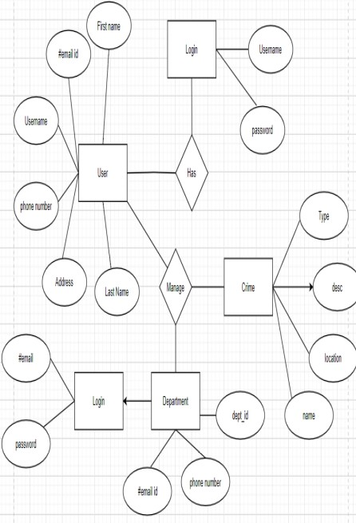

**Entity- Relationship diagram (E R diagram)**

Will describe all the works which is going to happen in the site in a simple and predictable manner. The main component of E R diagram are relationship set, entity set, associate degree, E R diagram show the relationship among entity set.

## Advantages

The main advantage of on-line application is that, an individual can report the crime anytime from anywhere**.**

Users can scan the progress of their grievance on- line

The details of the users/reporters won’t show

publicly

## Disadvantages

This application doesn’t allow users to recover

their identification.

#### 4.4 Use Case Diagram

A use case diagram acts as a focus for the description of user requirements. It describes the relationship between requirements, users and the major components. It does not describe the requirements in detail, these can be described in separate diagrams or in documents that can be linked to each use case.

**Basic Use Case** **Diagram Symbols and Notations**

* + - **System**

Draw your system’s boundaries using a rectangle that contains use cases .Place the actor outside

the system’s boundaries.

System Boundary:

* + - **Actors**

Actors are the users of the system. When one system is actor of another system, label the actor system with the actor stereotype.



Actor:

* + - **Use Case**

Draw use case casing ovals. Label the ovals with verbs that represent the system’s functions.

Use Case:

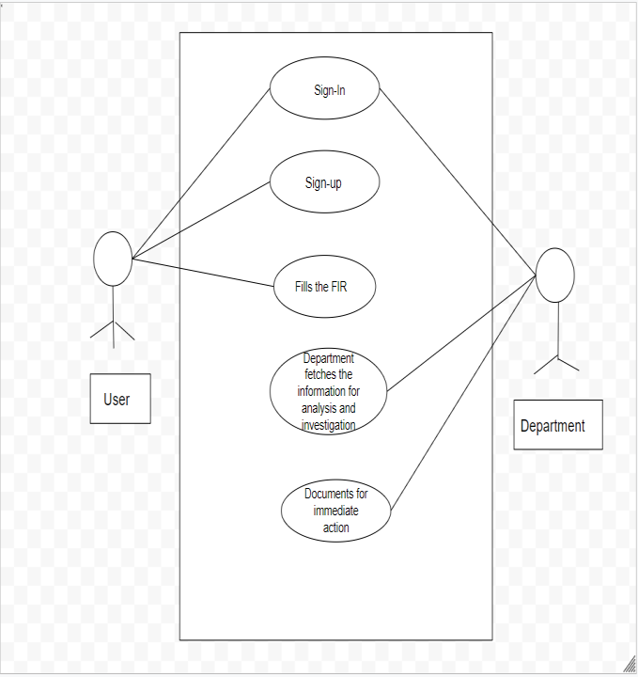

#### 4.5 Database Design

A database is a collection of logically related data designed to meet the information needs of one or more users. It is a collection of records stored in a computer in a systematic way. The general theme behind a database is to integrate all the information. A database is an integrated collection of data and provides centralized access to the data.

A database is a collection of interrelated data stored with minimum redundancy to serve many users quickly and efficiently. The general objective of database is to make the data access easy, inexpensive and flexible the user. The main objectives of designing a database are Data Integration, Data Integrity and Data Independence.

In the database, all the information is stored in the form of tables. A table is simply a way of storing data in rows and columns. In the system the data is stored in many tables. There are 8 tables used to store data.

#### Tables

1. [**complaint**](http://localhost/phpmyadmin/index.php?route=/sql&db=crime_portal&table=complaint&pos=0)

Top of Form

|  |  | **#** | **Name** | **Type** | **Null** | **Default** |
| --- | --- | --- | --- | --- | --- | --- |
|  |  | 1 | **c_id Primary** | int(11) | No | *None* |
|  |  | 2 | **a_no** | bigint(12) | No | *None* |
|  |  | 3 | **location** | varchar(50) | No | *None* |
|  |  | 4 | **type_crime** | varchar(50) | No | *None* |
|  |  | 5 | **d_o_c** | date | No | *None* |
|  |  | 6 | **description** | varchar(7000) | No | *None* |
|  |  | 7 | **inc_status** | varchar(50) | Yes | Unassigned |
|  |  | 8 | **pol_status** | varchar(50) | Yes | null |
|  |  | 9 | **p_id** | varchar(50) | Yes | Null |

Bottom of Form

1. [**head**](http://localhost/phpmyadmin/index.php?route=/sql&db=crime_portal&table=head&pos=0)

Top of Form

|  | **#** | **Name** | **Type** | **Null** | **Default** |
| --- | --- | --- | --- | --- | --- |
|  | 1 | **h_id** | varchar(50) | No | *None* |  |  |  |  |  |
|  | 2 | **h_pass** | varchar(50) | No | *None* |  |  |  |  |  |

Bottom of Form

1. [**police**](http://localhost/phpmyadmin/index.php?route=/sql&db=crime_portal&table=police&pos=0)

|  | **#** | **Name** | **Type** | **Null** | **Default** |
| --- | --- | --- | --- | --- | --- |
|  | 1 | **p_name** | varchar(50) | No | *None* |  |  |
|  | 2 | **p_id Primary** | varchar(50) | No | *None* |  |  |
|  | 3 | **spec** | varchar(50) | No | *None* |  |  |
|  | 4 | **location** | varchar(50) | No | *None* |  |  |
|  | 5 | **p_pass** | varchar(50) | No | *None* |  |  |

Bottom of Form

1. [**police_station**](http://localhost/phpmyadmin/index.php?route=/sql&db=crime_portal&table=police_station&pos=0)

|  | **#** | **Name** | **Type** | **Null** | **Default** |
| --- | --- | --- | --- | --- | --- |
|  | 1 | **i_id Primary** | varchar(50) | No | *None* |  |  |  |  |  |
|  | 2 | **i_name** | varchar(50) | No | *None* |  |  |  |  |  |
|  | 3 | **location Index** | varchar(50) | No | *None* |  |  |  |  |  |
|  | 4 | **i_pass** | varchar(50) | No | *None* |  |  |  |  |  |

Bottom of Form

1. [**update_case**](http://localhost/phpmyadmin/index.php?route=/sql&db=crime_portal&table=update_case&pos=0)

Top of Form

|  | **#** | **Name** | **Type** | **Null** | **Default** |
| --- | --- | --- | --- | --- | --- |
|  | 1 | **c_id** | int(11) | No | *None* |  |  |  |  |  |
|  | 2 | **d_o_u Index** | timestamp | No | current_timestamp() |  |  |  |  |  |
|  | 3 | **case_update** | varchar(200) | No | *None* |  |  |  |  |  |

Bottom of Form

1. [**user**](http://localhost/phpmyadmin/index.php?route=/sql&db=crime_portal&table=user&pos=0)

Top of Form

|  | **#** | **Name** | **Type** | **Null** | **Default** |
| --- | --- | --- | --- | --- | --- |
|  | 1 | **u_name** | varchar(50) | No | *None* |
|  | 2 | **u_id Index** | varchar(50) | No | *None* |
|  | 3 | **u_pass** | varchar(50) | No | *None* |
|  | 4 | **u_addr** | varchar(100) | No | *None* |
|  | 5 | **a_no Primary** | bigint(12) | No | *None* |
|  | 6 | **gen** | varchar(15) | No | *None* |
|  | 7 | **mob Index** | bigint(10) | No | *None* |

Bottom of Form

**4.6 User Interface Design**

User interfaces are simple web forms that can be operated even by a user that have no computer knowledge. In this system user interfaces are created using HTML (Hyper Text Mark-up Language). The system provides friendly user interfaces are provided for each functions. Separate user interfaces are provided for each function. Each function can be selected by clicking the corresponding link.

In the case of data entry forms, data can be entered in the corresponding textboxes or select it from dropdown list. The functions such as save, update etc. can be done by clicking the button.

In the case of searching a record, the details are specified either using dropdown list or by entering in the textbox. The system search for the record with the specified details and display it for

the user. In the case of request sanctioning, radio button is used for specifying either it is accepted or rejected.

A detailed plan and picture of user interface screens is given in section.

**SCREENSHOTS :**

1. **Home Page**

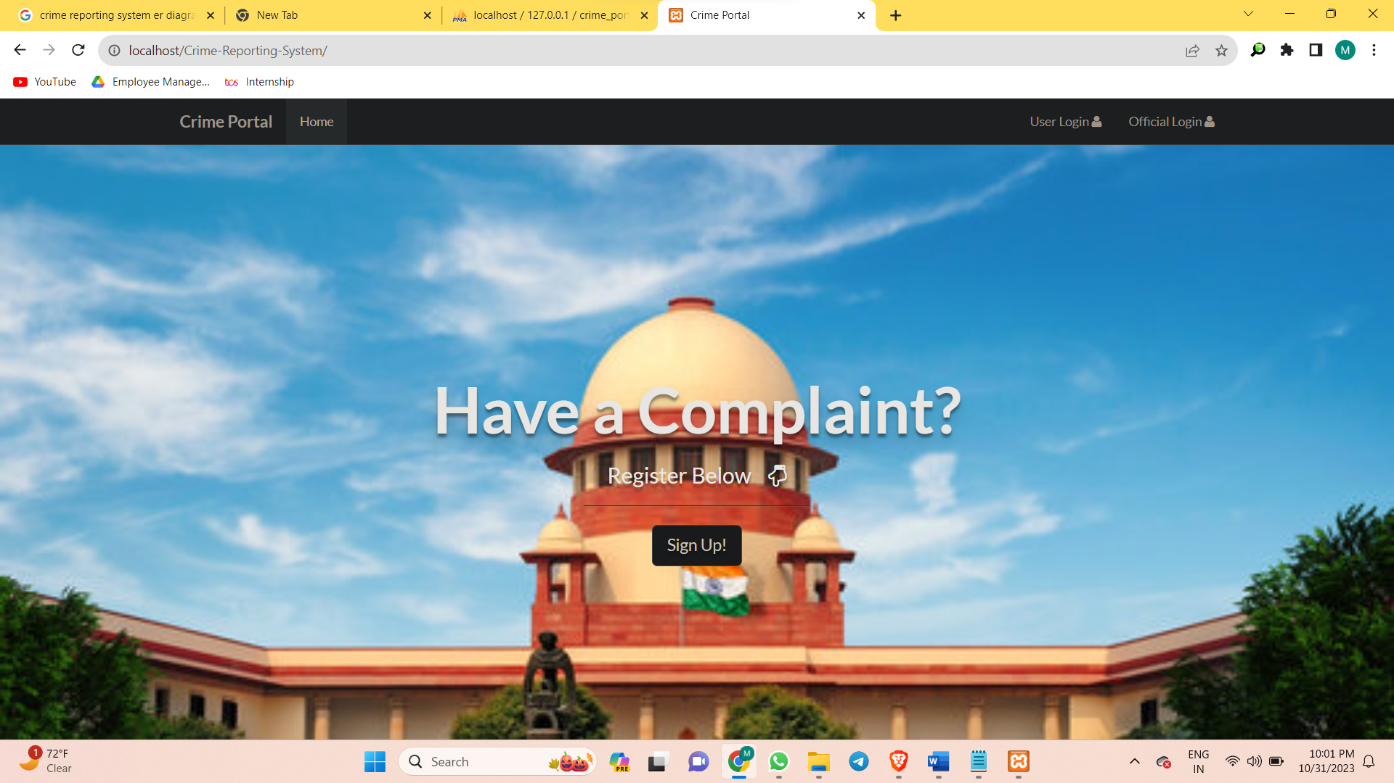

1. **Registration Page**

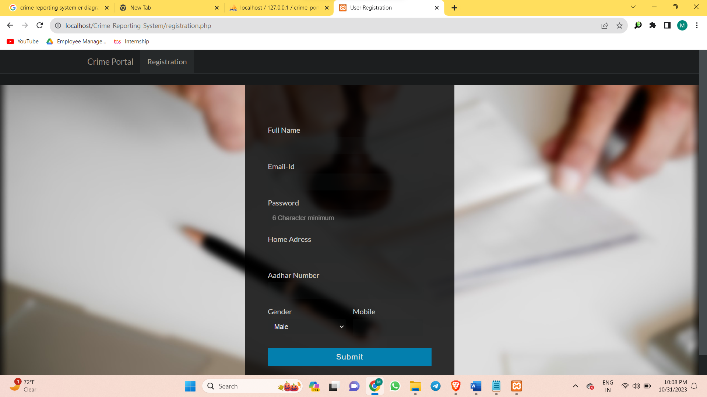

1. **User Login**

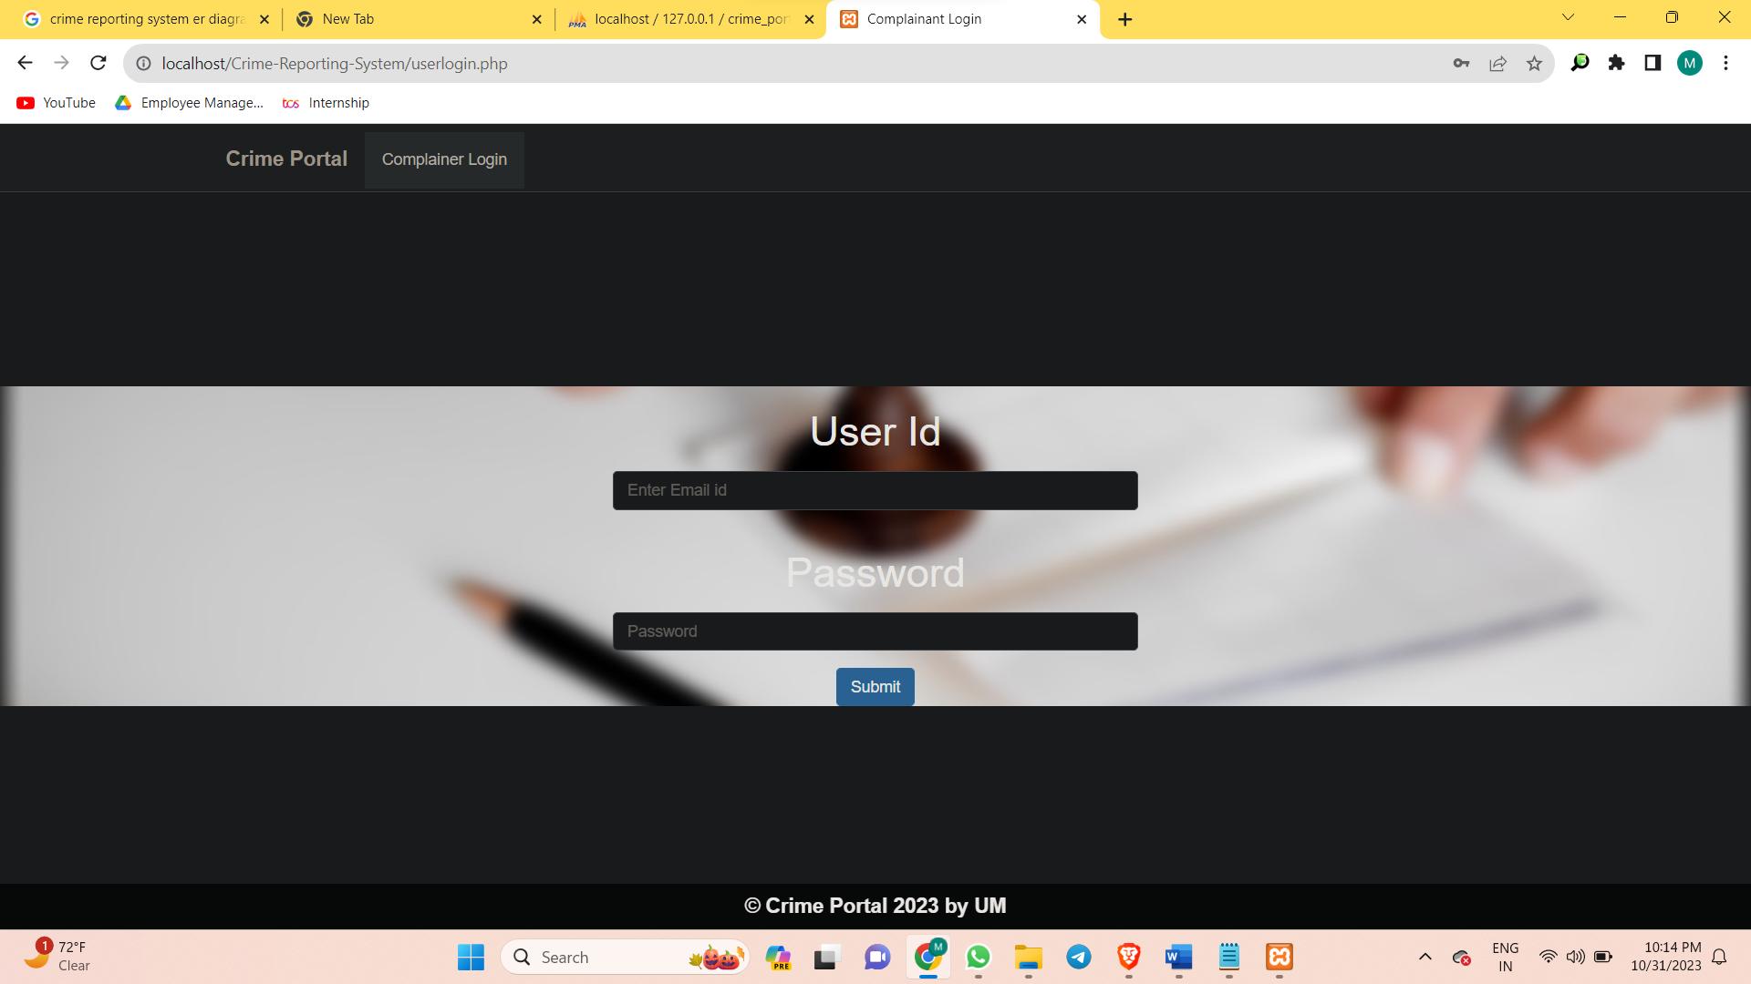

1. **Official Login**

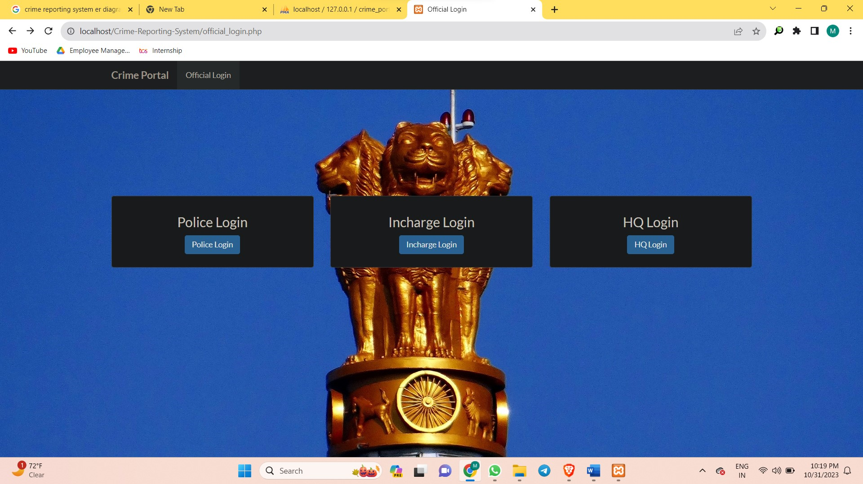

1. **Complaint History**

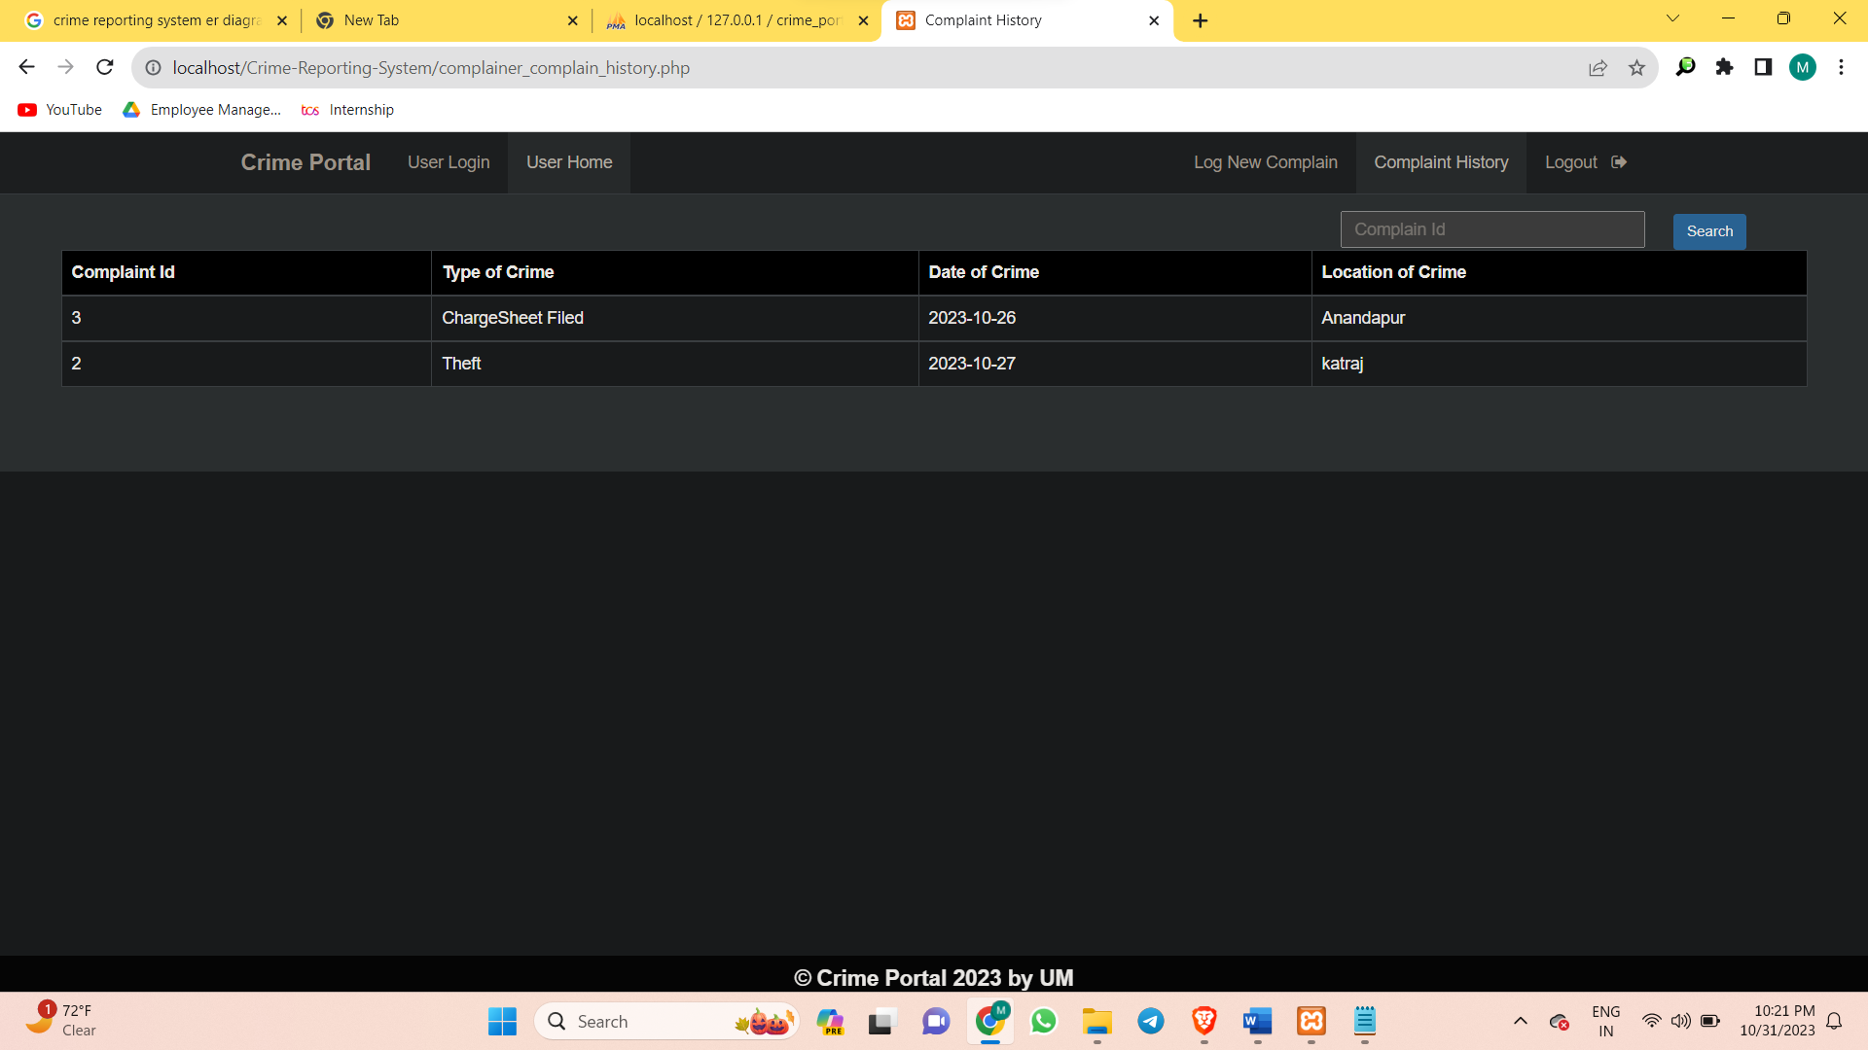

1. **Incharge Home**

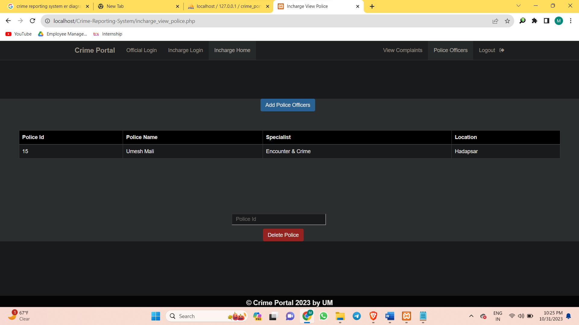

1. **View Complaints**



# SYSTEM TESTING

#### 5.1 Introduction

#### Unit Testing

At the lowest levels unit testing where different modules are tested against the specification produced during design for the modules. Unit design is essential for the verification of the code produced during the coding phase, and hence the goal is to test the internal logic of the modules. Each program unit and form modules are tested rigorously during the development and again before interconnecting these modules. During the time program, unit testing emphasis is on the correctness of procedures program logic, control flow, etc.

#### Integration Testing

In this level of testing many tested modules are combined into subsystems, which are then tested. The goal here is to see is the modules can be integrated properly, the emphasis being on testing interfaces between modules. The tested form modules are integrated and tested for correct interfaces, parameter passing, coordinated operation and such issues using simple data collected from the actual documents an files already available with the department. Top down integration strategy is employed for integration testing.

#### Validation Testing

Validation succeeds when the developed software function in a manner that can reasonably be expected by the user.

The system is ensured that the software specification is satisfied. The user of non-developers tests it. System testing is stage of implementation, which is aimed at ensuring that the system works accurately and efficiently before live operation commences. The principle, system providing is an ongoing activity throughout the project. The logical design and the physical design should be thoroughly and continually examined on paper to ensure that they will work when implemented Thus the system test in implication should be confirmation that all is correct and an opportunity to show the user that the system works.

# FUTURE ENHANCEMENT

Nothing can be ended in a single step. It is the fact that nothing is permanent in this world. So this project also has some future enhancements in the evergreen and booming IT industry. Change is inevitable. The project entitled “Crime Reporting System” was successfully designed developed and tested. The system architecture is compatible one, so addition of new modules can be done without much difficulty .Since this module has its unique properties it can extend further to make this system a complete one.

Scope of further development

The various future enhancement which shall include:

* + We look forward to working with the Government in implementing the recommendations and seeing an improvement in the effectiveness of the Police Department.
  + The method of video conferencing can added to make the project lively.
  + More Graphics can be added to make it more user-friendly and understandable.
  + Add facility of missing persons.

# CONCLUSION

##### The project entitled ”Crime Reporting System” is a website which provides the facility for reporting crime online, view status of the report, show most wanted criminal details. This software is developed with scalability in mind. Additional modules can be easily added when necessary. The software is developed with modular approach .All modules in the system have been tested with valid data and invalid data and everything work successfully. The project has been completed successfully with the maximum satisfaction. The constraints are met and overcome successfully.

The system is flexible and versatile. This software has a user-friendly screen that enables the user to use without any inconvenience.

##### Validation checks induced have greatly reduced errors. Provisions have been made to upgrade the software. The application has been tested with live data and has provided a successful result. Hence the software has roved to work efficiently.

# BIBLIOGRAPHY

**Crime Reporting System- By Y. Yugandhar, BMuni Archana**

[**www.nevnprojects.com**](http://www.nevnprojects.com)

[**www.enggroom.com**](http://www.enggroom.com)

[**www.projectsworlds.in**](http://www.projectsworlds.in)

**Services.lovelycoding.org**

**Crime Reporting System-ijirt**